About Deacons …
They must keep hold of the deep truths of the faith with a clear conscience.
— I Timothy 3:9
In I Timothy 3:8-13, Paul gives the qualifications for those who desire to serve as deacons. The first verse in this passage teaches us an important point: "Deacons, likewise, are to be men worthy of respect, sincere, not indulging in much wine, and not pursuing dishonest gain" – I Timothy 3:8. The word, "likewise," is important to understanding this passage properly. In the verses immediately before this passage (I Timothy 3:1-7), Paul provided the qualifications for the position of an elder. In discussing the qualifications for an elder, Paul mentions the "office of an elder" and states that "An elder then must be blameless ..." (I Timothy 3:1-2). Just as an "elder must be ... ," a deacon "likewise must be ... ." The word "likewise" connects the two as offices that require specific qualifications for appointment.
Therefore, just as the word "elder" denotes a specific office, the word "deacon" denotes a specific office, with qualifications listed below:
Likewise must the deacons be grave, not doubletongued, not given to much wine,
not greedy of filthy lucre; Holding the mystery of the faith
in a pure conscience. And let these also first be proved; then let them use the office
of a deacon, being found blameless. Even so must their wives be grave,
not slanderers, sober, faithful in all things. Let the deacons be the husbands of one wife, ruling their children and their own houses well.
For they that have used the office of a deacon well purchase to themselves a good degree, and great boldness in the faith which is in Christ Jesus.
— I Timothy 3:8-11

Webb Chapel Deacons

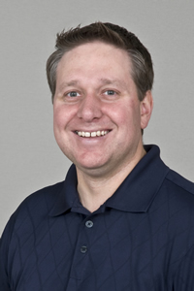Dennis Bartley
Dennis has served as a deacon since 2006. He and his wife Julie placed membership at Webb Chapel in 1997. Dennis serves as Deacon over the Children's Ministry which is referred to as WebbKids. WebbKids encompasses all activities (except Bible Classes) for our children ages 2 through 5th grade and their families. Dennis is assisted by his wife Julie with WebbKids activities which include but are not limited to Fall Festival, VBS, and WebbKids Worship. Dennis and Julie are co-leaders of a Small Group. Dennis and Julie were married in 1996 and have 3 children, twins William and Grant and daughter Claire.

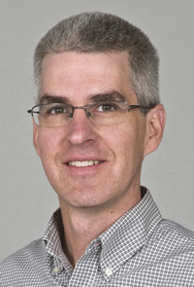Greg Chandler
Greg has served as a deacon since 2006. He and his wife Donelle placed membership at Webb Chapel in 1998. Greg very ably led the Missions Ministry for many years. Donelle serves as Education Coordinator of Primary and Intermediate Departments covering 1st through 5th grade and is active in ladies’ class activities. Greg and Donelle also are Small Group Leaders. They have two children, Garrett & Jara.

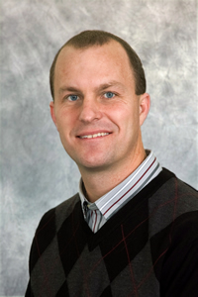David Day
David has served as a deacon since 2006. David & Lisa were married in 1996, and they placed membership at Webb Chapel in 1996. He serves as Deacon over Retreats and Special Projects. He is Ministry Leader of Communion Servers and Men's Activities. David and Lisa are Ministry Co-Coordinators of the Care Group Ministry. They also are Small Group Leaders. Both are involved with all activities of our youth. David and Lisa are the parents of Alexander and Aubrey.

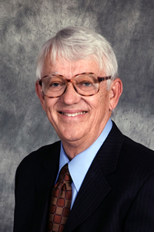Ron Dunn
Ron has served as a deacon since 1984. Ron & Patti were married in 1968. He and his family placed membership at Webb Chapel in 1976. Ron and Patti are the parents of daughter Leslie and husband Erick Mida of Frisco, Texas, and of son Brad of Dallas. They have three grandchildren.

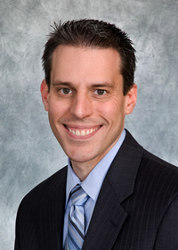Ged Erwin
Ged has served as deacon since 2011. Ged and Jodie were married in 2001, and they came to Webb Chapel in 2008. Ged serves as Deacon of Health & Wellness, generously utilizing his medical knowledge and expertise. Ged and Jodie are the parents of Callahan and Isabelle Clarice.

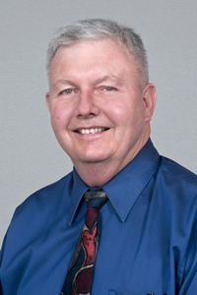Bob Fellers
Bob has served as a deacon since 1984. Bob and his wife, Lynne, were married in 1974. Lynne grew up at Webb Chapel, and they placed membership together in 1977. Bob served as Deacon over Transportation for many years. He is Ministry Leader over Ushers and Attendance Counting. Lynne is frequently involved in children's Bible Classes. Bob and Lynne are the parents of two daughters, Lindsay and husband Derek Crites of McKinney and daughter Lauren of New York City.

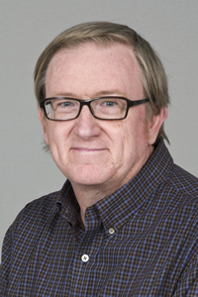John Gattis
John has served as deacon since 2011. John grew up at Webb Chapel, and his wife Crystal came to Webb Chapel in 1994. They were married in 1995. John serves as Deacon over ESL, a program in which he has been involved for many years. Crystal is involved in children’s classes and lends her artistic talents wherever they are needed. John and Crystal have one son, Zachary (Weisbard).

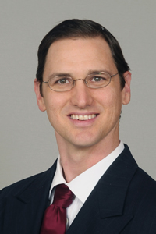Jeremy Ketchersid
Jeremy has served as deacon since 2011. Jeremy and Crissy were married in 1997. They came to Webb Chapel in 2008. Jeremy serves as Deacon of Children’s Homes. He and Crissy are deeply involved in youth activities. Together they coordinate Leadership Training for Christ each year. Jeremy and Crissy have two daughters, Tebessa and Allison.

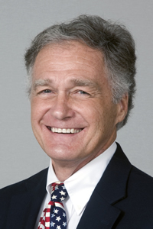Bondey Mays
Bondey has served as deacon since 2011. Bondey and Jan were married in 1969. They came to Webb Chapel in 2001. Bondey serves as Deacon of the Spanish Ministry, and he and Jan work closely with our Spanish-speaking members. He also emcees PT Cruzer meetings. Bondey and Jan are the parents of daughter Kelly and husband DJ Overman and son Jordan. They have 4 grandchildren.

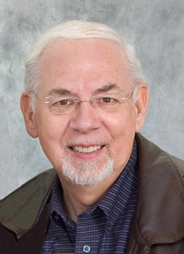Mike Swayne
Mike has served as a deacon since 1988. Mike & Judi were married in 1967, and they placed membership at Webb Chapel in 1973. Mike serves as Deacon over the Audio and Tape Ministry as well as Auditorium Sound. Judi has been active in children’s classes. They are the parents of Eric and wife Larissa of Dallas who have given them three grandchildren.

